Experiment 11: 8-Queens Problem
Aim: To write a Python program to solve the 8-Queens problem using backtracking.
Algorithm:
- Start the program.
- Place a queen in the first row.
- Check whether the position is safe from other queens.
- If safe, place the queen and move to the next row.
- If no safe position exists, backtrack.
- Continue until all eight queens are placed.
- Display the solution.
- Stop the program.
Code:
N = 8
board = [-1] * N
def is_safe(row, col):
for i in range(row):
if board[i] == col:
return False
if abs(board[i] - col) == abs(i - row):
return False
return True
def solve(row):
if row == N:
return True
for col in range(N):
if is_safe(row, col):
board[row] = col
if solve(row + 1):
return True
board[row] = -1
return False
if solve(0):
for row in range(N):
for col in range(N):
if board[row] == col:
print("Q", end=" ")
else:
print(".", end=" ")
print()
else:
print("No solution exists")
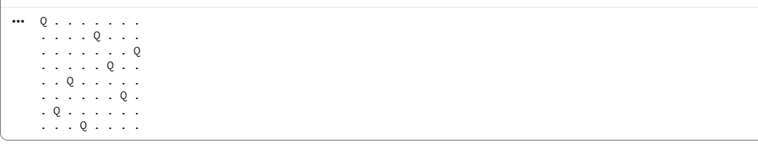
Output:
Result:
Thus, the Python program to solve the 8-Queens problem using backtracking was executed successfully.
Experiment 12: Water Jug Problem
Aim: To write a Python program to solve the Water Jug Problem using Breadth-First Search (BFS).
Algorithm:
- Start the program.
- Initialize two jugs with capacities of 4 litres and 3 litres.
- Set the target amount to 2 litres.
- Generate possible states by filling, emptying, or transferring water between jugs.
- Use BFS to explore the states.
- Stop when the target amount is reached.
- Display the solution path.
- Stop the program.
Code:
from collections import deque
def water_jug():
capacity1 = 4
capacity2 = 3
target = 2
queue = deque([((0, 0), [])])
visited = set()
while queue:
(x, y), path = queue.popleft()
if (x, y) in visited:
continue
visited.add((x, y))
path = path + [(x, y)]
if x == target or y == target:
return path
states = [
(capacity1, y),
(x, capacity2),
(0, y),
(x, 0),
(x - min(x, capacity2 - y),
y + min(x, capacity2 - y)),
(x + min(y, capacity1 - x),
y - min(y, capacity1 - x))
]
for state in states:
if state not in visited:
queue.append((state, path))
return None
solution = water_jug()
if solution:
print("Solution steps:")
for state in solution:
print(state)
else:
print("No solution found")
Output:
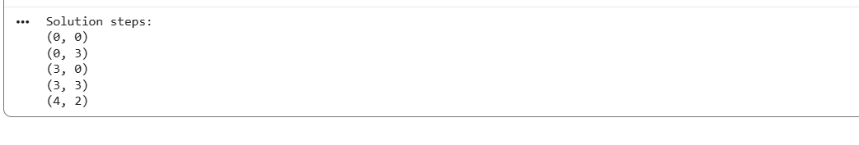
Result:
Thus, the Python program to solve the Water Jug Problem using BFS was executed successfully.
Experiment 13: Crypt-Arithmetic Problem
Aim: To write a Python program to solve a crypt-arithmetic problem in which each letter represents a unique digit.
Algorithm:
- Start the program.
- Define the words SEND, MORE, and MONEY.
- Assign different digits to the letters.
- Ensure that the first letter of each word is not zero.
- Check whether SEND + MORE = MONEY.
- Display the valid digit assignment.
- Stop the program.
Code:
from itertools import permutations
letters = "SENDMORY"
for digits in permutations(range(10), len(letters)):
d = dict(zip(letters, digits))
if d["S"] == 0 or d["M"] == 0:
continue
send = (d["S"] * 1000 + d["E"] * 100
+ d["N"] * 10 + d["D"])
more = (d["M"] * 1000 + d["O"] * 100
+ d["R"] * 10 + d["E"])
money = (d["M"] * 10000 + d["O"] * 1000
+ d["N"] * 100 + d["E"] * 10
+ d["Y"])
if send + more == money:
print("SEND =", send)
print("MORE =", more)
print("MONEY =", money)
break
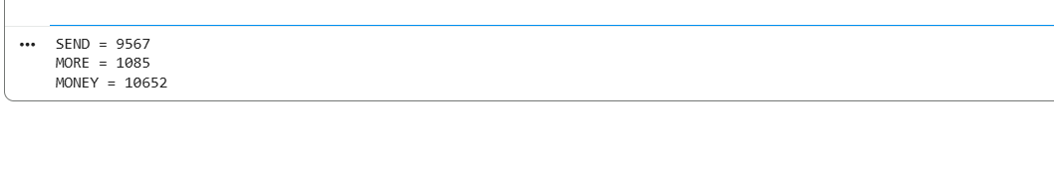
Output:
Result:
Thus, the Python program to solve the crypt-arithmetic problem was executed successfully.

Experiment 14: Missionaries and Cannibals Problem
Aim: To write a Python program to solve the Missionaries and Cannibals Problem using BFS.
Algorithm:
- Start the program.
- Initialize three missionaries and three cannibals on the left bank.
- Define the boat capacity as two people.
- Generate valid boat movements.
- Ensure missionaries are never outnumbered by cannibals on either bank when missionaries are present.
- Use BFS to find a valid sequence of crossings.
- Display the solution.
- Stop the program.
Code:
from collections import deque
def valid(m, c):
if not (0 <= m <= 3 and 0 <= c <= 3):
return False
# Left bank
if m > 0 and m < c:
return False
# Right bank
mr = 3 - m
cr = 3 - c
if mr > 0 and mr < cr:
return False
return True
def solve():
start = (3, 3, 0)
goal = (0, 0, 1)
moves = [(1, 0), (2, 0), (0, 1),
(0, 2), (1, 1)]
queue = deque([(start, [start])])
visited = {start}
while queue:
state, path = queue.popleft()
if state == goal:
return path
m, c, boat = state
for dm, dc in moves:
if boat == 0:
new_state = (m - dm, c - dc, 1)
else:
new_state = (m + dm, c + dc, 0)
if valid(new_state[0], new_state[1]):
if new_state not in visited:
visited.add(new_state)
queue.append(
(new_state, path + [new_state])
)
return None
path = solve()
if path:
print("M, C, Boat (0=Left, 1=Right)")
for state in path:
print(state)
else:
print("No solution found")

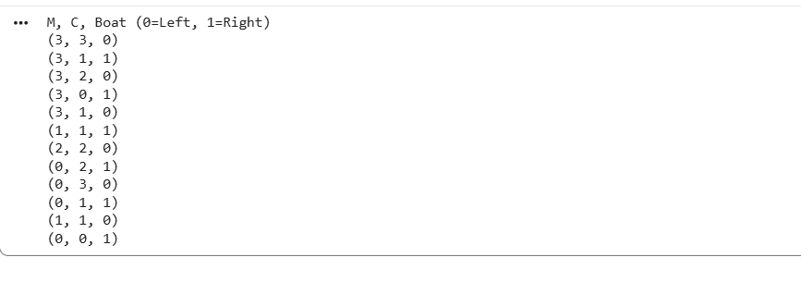
Output:
Result:
Thus, the Python program to solve the Missionaries and Cannibals Problem using BFS was executed successfully.
Experiment 15: Vacuum Cleaner Problem
Aim: To write a Python program to implement the Vacuum Cleaner Problem using a simple reflex agent.
Algorithm:
- Start the program.
- Initialize two rooms, A and B, with their cleanliness status.
- Place the vacuum cleaner in room A.
- Check whether the current room is dirty.
- If dirty, clean the room.
- Move to the next room and repeat.
- Display the final room status.
- Stop the program.
Code:
rooms = {
"A": "Dirty",
"B": "Dirty"
}
location = "A"
while True:
print("Vacuum is in room", location)
if rooms[location] == "Dirty":
rooms[location] = "Clean"
print("Room", location, "cleaned")
if location == "A":
location = "B"
else:
break
print("Final room status:", rooms)
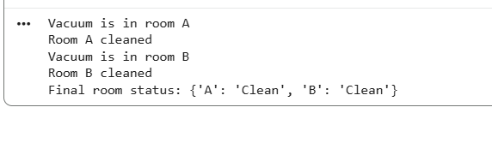
Output:

Result:
Thus, the Python program to implement the Vacuum Cleaner Problem using a simple reflex agent was executed successfully.

